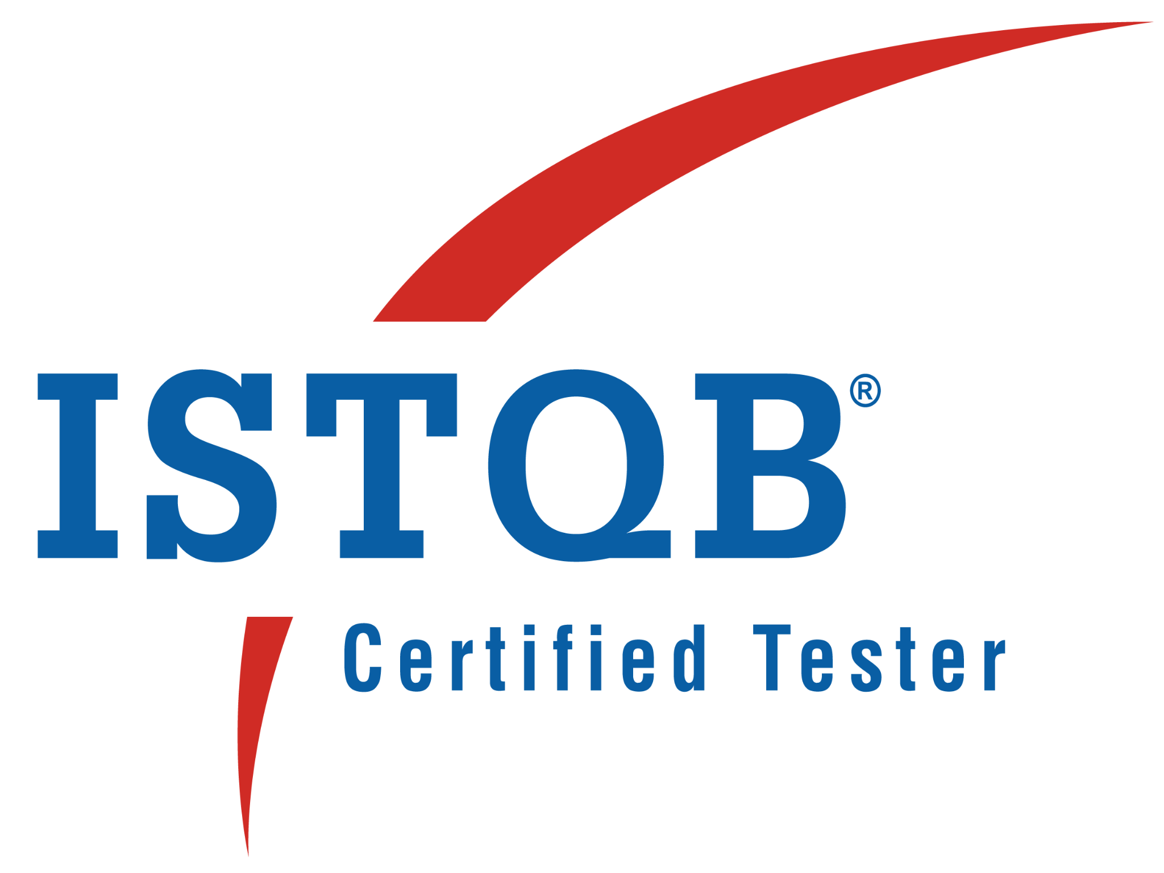
Vineela Gummakonda 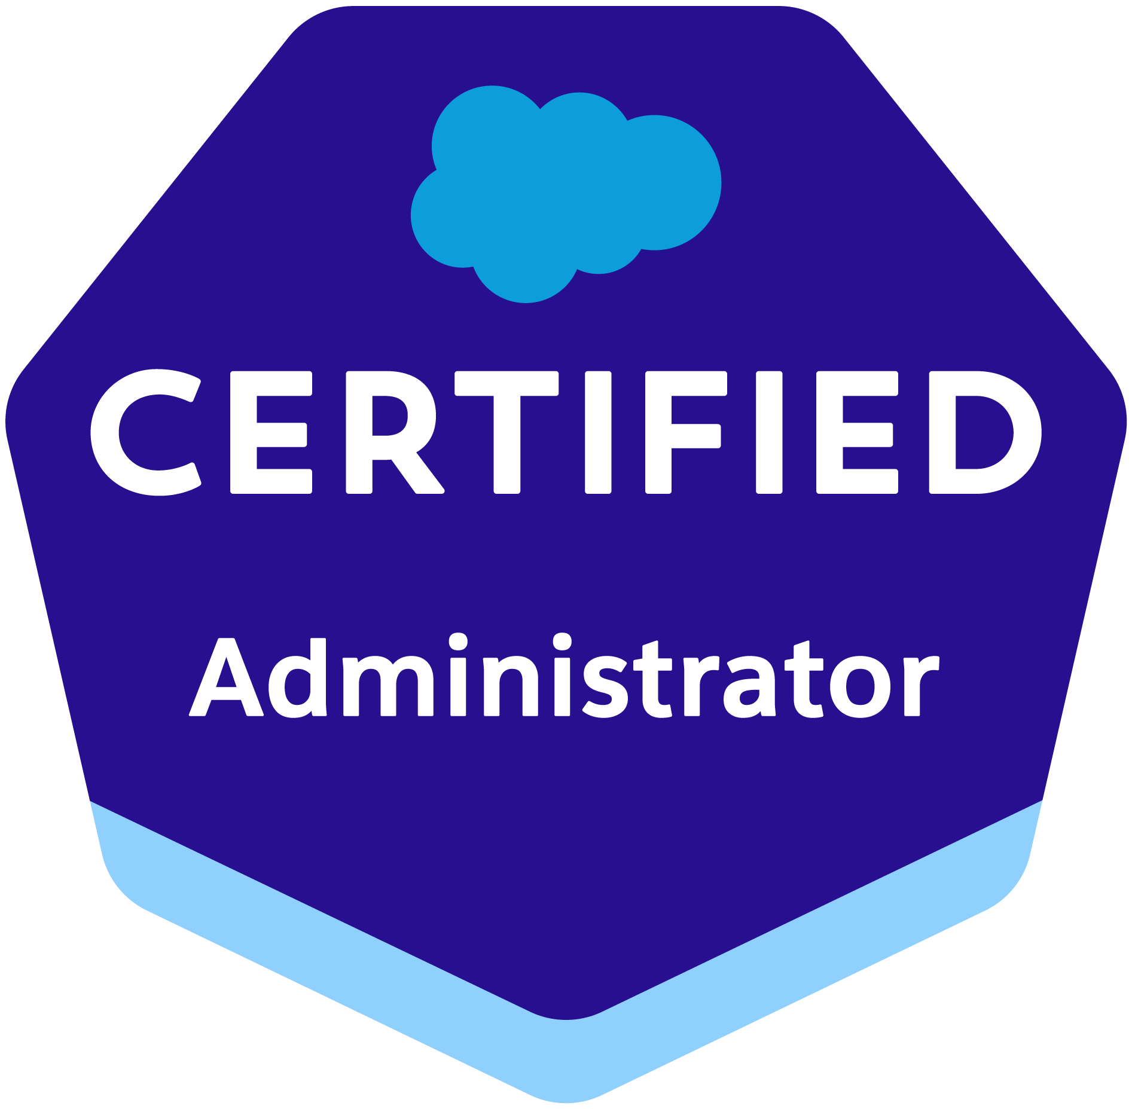

Email Id vineela.vin7@gmail.com Contact number +1(248)-472-4477

A 13+ years IT professional with 9 years in Salesforce Administration & Development, and 4 years in Quality Assurance. Possess strong communication, problem-solving, and project management skills, combined with a deep understanding of Salesforce eco system and best practices

SUMMARY:
- As a Salesforce Administrator/Developer, experience in Salesforce CRM administration, Configuration and Customization
- Expertise in creating Custom Objects, Custom Fields, Tabs, Apps, Page Layouts, Record Types, Field Dependencies, Formula fields, Custom Validation Rules ad Relationships as per the business requirements
- Worked on configuring security settings using Profiles, Permission Sets, Roles, OWD, Sharing Rules
- Worked on Data Migration activities using Apex Data Loader, Import Wizard and Data Export
- Worked on automating complex business processes using Workflow rules, Approval process, Process builder and Flows
- Worked on creating Public Groups and Queues
- Developed and configured various Dashboards, Reports and Report Folders for different user profiles based on the requirements
- Experience using SOQL, SOSL and DML Operations
- Developed Apex Classes, Apex triggers, Batch Apex, Schedule Apex, Test classes, Visualforce pages, and integrating with external sources by developing SOAP, RESTful Apex Web Services, and Force.com API
- Developed Visual force pages, Aura components and LWC. Good with HTML, CSS and JavaScript
- Experience in creating Lookup Relationships and Master-detail Relationships on the objects and creation of junction objects to establish connectivity among other objects.
- Experience in maintaining the Functional areas of Data Management, Forecasting, Accounts, Contacts, Leads, Campaigns, Opportunities, Quotes, Activities, Dashboards and Reports
- Worked on Salesforce Email Studio for Email creation, personalization, segmentation and configuring email campaigns, dynamic email templates and segmented campaigns
- Good knowledge on configuring Sender Policy Framework (SPF) and Domain Keys Identified Mail (DKIM) email authentication
- Experience configuring and customizing the Salesforce sales, marketing, service, experience cloud and Salesforce CPQ
- Experience in integration using SOAP API, REST API, Platform Events and Change Data Capture events. Used XML, JSON and WSDL
- Creating and maintaining comprehensive documentation outlining processes, policies and Salesforce help resources
- As an ETL Quality Analyst, experience validating data sources, data transformations, data marts and reports across various databases
- Extensive knowledge in ETL Testing, BI report testing, Functional Testing, Webservices testing and User Interface Testing
- Experience in test planning and execution along with test artefacts at each level like test plans, test cases and test reports
- Experience in performing Sanity testing and Regression testing
- Well versed with Test Management tools HP ALM, JIRA, Zephyr, qTest and Target Process
- Ability to work collaboratively with Business stakeholders, testing teams, Developers and other team members to enhance the overall software product quality

SKILLS
- Agile, Scrum, Kanban  - App Exchange products/solutions  - Cross-functional team collaboration  - Lightning Experience  - Salesforce Analytics  - Salesforce Configuration  - Report & Dashboards building | - Security management  - Service and Experience Cloud Management  - Sales Cloud Management  - Marketing Cloud  - Data Migration  - Apex Classes, Triggers  - Postman  - Visualforce, HTML, CSS, JavaScript, LWC, Integration, Salesforce Connections | - Java, Email Studio  - Email campaigns, Dynamic Email templates, Segmented campaigns  - Git, Bitbucket, VSCode  - HP ALM, JIRA, Confluence, qTest, Xray, Zephyr, Target Process

EXPERIENCE

Company: A Squared Consulting Business, March-2024 to Present
Implementation: Virtusa
Client: JP Morgan Chase
Role: Lead Salesforce Developer
- Worked on implementing client’s Business banking business central Service cloud which will be used by Bankers and Operations support team
- Worked on converting existing Aura components to LWC and also implemented enhancements
- Worked on mobile enhancements for making the client’s service app compatible with mobile devices
- Worked on developing lighting components for client discovery and call planning to be used by bankers
- Developed various Custom Objects, Components, Controllers, Custom Reports, Custom Tabs, Labels, Validation rules, Approval Processes and Auto-Response rules for automating business logic and Report folders for different users and profiles based on the requirement.
- Worked on monthly deployment activities and defect fixes
- Have involved in updating user manuals as per the enhancements done and conducting use trainings and demos
- Environment: Salesforce.com platform, Lightning, SOQL, SOSL, DML, Service cloud, Apex Language, Visualforce, Aura, LWC, Data Loader, HTML, CSS, Java Script, Workflow & Approvals, Reports, Custom Objects, Custom Tabs, JIRA, User Stories

Company: ZyroTek PVT LTD, Aug-2023 to Jan 2024
Client: Benjamin Moore
Role: Salesforce Developer
- Worked on implementing and optimizing client’s Sales process and marketing cloud with Salesforce.com platform having 200+ users
- Worked on handling end to end Email Campaigns. Performed Salesforce Marketing Cloud initiatives including Developing and Maintaining large volumes of deadline-driven emails
- Involved in mapping the data fields and structures between the legacy system and the salesforce marketing cloud
- Worked on Salesforce Email Studio for Email creation, personalization, segmentation and configuring email campaigns, dynamic email templates to personalize email content based on subscriber attributes and segmented campaigns to send targeted and relevant email messages to specific audience segments
- Worked on automating email campaigns
- Worked on configuring SPF and DKIM
- Worked on creating Email Campaigns and Dynamic Email Templates
- Worked on creating and deploying digital campaign initiatives as per business requirements
- Environment: Salesforce.com platform, Lightning, SOQL, SOSL, DML, Sales cloud, Marketing Cloud, Apex Language, Java, Visualforce, Data Loader, HTML, CSS, Java Script, Workflow & Approvals, Reports, Custom Objects, Custom Tabs, JIRA, User Stories, Email studio, email campaigns, dynamic email templates, segmented campaigns, SPF, DKIM

Company: Infosys, Client: Proximus, June-2022 to July-2023
Role: Salesforce Developer
- Worked on Service cloud and Marketing cloud initiatives
- Worked on handling end to end Email Campaigns. Performed Salesforce Marketing Cloud initiatives including Developing and Maintaining large volumes of deadline-driven emails
- Reporting on email campaigns (status and outcomes) for various stakeholders. Cross departmental collaboration on major projects and new initiatives.
- Effectively communicate between technical, operational and strategy groups. Created many Data extensions to accommodate custom scenarios. Configured and designed journey's using journey Builder
- Involved in mapping the data fields and structures between the legacy system and the salesforce marketing cloud
- Worked on Salesforce Email Studio for Email creation, personalization, segmentation and configuring email campaigns, dynamic email templates to personalize email content based on subscriber attributes and segmented campaigns to send targeted and relevant email messages to specific audience segments
- Worked on automating email campaigns, campaign journeys and data imports
- Configured and managed marketing automation process and workflows using Automation Studio
- Worked on configuring SPF and DKIM
- Worked on creating Email Campaigns and Dynamic Email Templates
- Worked on creating and deploying digital campaign initiatives as per business requirements
- Environment: Salesforce.com platform, Lightning, SOQL, SOSL, DML, Marketing Cloud, Service cloud, Apex Language, Visualforce, Aura, LWC, Data Loader, HTML, CSS, Java Script, Workflow & Approvals, Reports, Custom Objects, Custom Tabs, JIRA, User Stories, Email studio, email campaigns, dynamic email templates, segmented campaigns

Company: TCS, Client: BT, May-2019 to Feb 2022
Role: Salesforce Admin/Dev
- Worked on configuring security settings using Profiles, Permission Sets, Roles, OWD, Sharing Rules
- Worked on Data Migration activities using Apex Data Loader, Import Wizard and Data Export
- Worked on automating complex business processes using Workflow rules, Approval process, Process builder and Flows
- Worked on creating Public Groups and Queues
- Developed and configured various Dashboards, Reports and Report Folders for different user profiles based on the requirements
- Developed Apex Classes, Apex triggers, Batch Apex, Schedule Apex, Test classes, Visualforce pages, and integrating with external sources by developing SOAP, RESTful Apex Web Services, and Force.com API
- Developed Visual force pages, Aura components and LWC. Good with HTML, CSS and JavaScript
- Experience in creating Lookup Relationships and Master-detail Relationships on the objects and creation of junction objects to establish connectivity among other objects.
- Worked on maintaining the Functional areas of Data Management, Forecasting, Accounts, Contacts, Leads, Campaigns, Opportunities, Quotes, Activities, Dashboards and Reports
- Developed client deliverables by project requirements and approved documentation standards.
- Conducted project-related presentations periodically to the management and stakeholders during project phases like grooming, development, and testing.
- Attending the meetings with the delegates and follow the testing process and guidelines
- Following the Agile/Scrum techniques and the ceremonies in the team for implementing all kinds of projects and consulting
- Create and review - Test scenarios, Test suite preparation, Test Data creation, Test case execution, and Defect logging
- Environment: Salesforce.com platform, Lightning, SOQL, SOSL, DML, Service cloud, Apex Language, Visualforce, Aura, LWC, Data Loader, HTML, CSS, Java Script, Workflow & Approvals, Reports, Custom Objects, Custom Tabs, JIRA, User Stories, RACI

Company: TCS, Client: Deutch Bank, Dec-2015 to May-2019
Role: Salesforce Admin/Dev
- Created custom Objects and also worked on Standard objects for customer’s Salesforce application having 500 users
- Created Custom Objects, Custom Fields, Tabs, Apps, Page Layouts, Record Types, Field Dependencies, Formula fields, Custom Validation Rules and Relationships as per the business requirements
- Automated business processes using Workflow rules, Process builder and Flow builder
- Implemented Apex Triggers, Apex Classes for automation of the business process on Account, Contact, Opportunity, and Custom Objects
- Developed custom LWC for the Sales Rep to see all the Accounts they are working with easy update of some fields on LWC for quick sales process
- Imported data from Excel sheets into Leads, Accounts, Contacts, and Opportunities using Data Loader and Import Wizard
- Responsible for deploying the components from one Sandbox environment to another Sandbox/Production environment using Force.com IDE tool and Change Sets
- Created and managed user accounts, profiles and roles
- Assigned appropriate permissions and access levels based on user roles and responsibilities
- Define and enforce data security policies using sharing settings, roles and permission sets
- Setup and manage field-level security to control access to specific fields on objects
- Developed and maintained reports and dashboards to provide insights into business performance
- Environment: Salesforce.com platform, Lightning, SOQL, SOSL, DML, Sales cloud, Service cloud, Apex Language, Visualforce Pages, Aura, LWC, Data Loader, HTML, CSS, Java Script, Integration, Workflow & Approvals, Reports, Custom Objects, Custom Tabs, Email Services, Security Controls, Sandbox data loading, VSCode, GitHub, Windows

Company: TCS, Client: Nordea, Oct-2012 to Dec-2015
Role: ETL Quality Analyst
- Involved in Requirement Analysis, Evaluation, Design, Development, and Implementation using Datastage
- Worked on Data validation, merging, cleansing, and aggregation activities
- Involved in ETL Functional testing. Involved in testing Reports. Requirements gathering and freezing of those requirements
- Utilized sources to target data mapping and Business rules associated with the ETL processes
- Analyze the requirements and frame test scenarios
- Validate the data in the target tables against source data for Sourcing & Ingestion which has 100+ target tables
- Validate the target container tables which has transformed data from Sourcing & Ingestion target tables
- Validate the Data Mart which is populated from container tables
- Regression testing for every release
- Testing of data received from various sources, processed and sent for credit risk calculations
- Involved in ETL testing, BI Micro strategy Dashboards, and reports testing
- Environment: JIRA, Oracle, DataStage, Database, SQL, Unix

Company: TCS, Client: M&S, Nov-2010 to Oct-2012
Role: ETL Quality Analyst
- Involving in the project project right from the project initiation – understand the Business Requirements Document (BRD) and High-Level Design Document (HLD). Static review of design documents
- Decreased the release defect density by 40% and increased the customer satisfaction
- Prepare a test plan and test scenarios – get it reviewed and signed off from the business stakeholders
- Test execution, report status, update QC on a daily basis
- Prepare Test Results Summary Report (TRSR) after the execution completion and sign off
- Validation of the sales data aggregated and loaded into the sales aggregation tables
- Validating the data sources, data transformations, data marts and reports for POS (Point of Sale) data
- Created ETL test data for all ETL mapping rules to test the aggregation and data transformations
- Performed Sanity and regression testing
- Worked collaboratively with Business stakeholders, developers and cross functional team members to enhance overall software product quality
- Environment: JIRA, DB2, DataStage, Database, SQL

EDUCATION AND PROFESSIONAL TRAINING
- Salesforce Certified Administrator
- Salesforce Certified Business Analyst
- Salesforce Certified Platform App Builder, Salesforce Certified Platform developer (Pursuing)
- ISTQB Foundation Certification
- Bachelor of Technology (B. Tech) from KLU affiliated to Acharya Nagarjuna University in Electrical and Electronics Engineering, Guntur, India, 2010

